**INTERNATIONAL VIDEO GAME SALES REPORT**

by

Afia Asamoah-Frimpong

**INTRODUCTION**

The video game industry has experienced tremendous growth over the years, shaping cultural trends and influencing entertainment consumption worldwide. Analyzing sales data can provide valuable insights into consumer preferences, platform performance, and market trends.

This report delves into a comprehensive dataset of over 16,500 video games with sales exceeding 100,000 copies. The aim of this analysis is to uncover trends, patterns, and relationships within the data using Power BI as the primary analytical tool.

**METHODOLOGY**

The dataset contains key fields, made up of both quantitative and qualitative elements, that detail the sales performance of video games across different regions and platforms. Before analysis, the data underwent a series of preparation steps. The dataset was imported and loaded into Power BI, allowing for effective visualization and analysis capabilities. Each field in the dataset was reviewed to understand its structure:

* Rank: Numeric rank of overall sales.
* Name: Textual representation of the game title.
* Platform: Categorical data indicating the platform of release.
* Year: Year of release (in numeric format).
* Genre: Categorical data indicating the genre.
* Publisher: Categorical data indicating the publisher.
* Sales: Numeric fields for sales in various regions and global sales (in millions of dollars). “NA_Sales” represents sales in North America, “EU_Sales” represents sales in Europe, “JP_Sales” represents sales in Japan, “Other_Sales” represents sales in the rest of the world, and “Global_Sales” represents total worldwide sales.

Data quality is crucial for reliable analysis and hence cleaning steps were implemented using Power Query. Missing values were identified and handled, particularly in fields such as Publisher and Genre, which were crucial for analysis. Data types of the various fields were verified to ensure that all fields were correctly formatted. For example, numeric fields were confirmed as such, and categorical fields were appropriately classified. Sales figures were analyzed for outliers, particularly in global sales.

Outliers were examined to ensure they represented valid data points and not errors. Genre and platform names were standardized or normalized to ensure consistency (e.g., “XBOX” vs. “Xbox”). Duplicate records were also eliminated from the dataset to avoid redundancy. Calculated columns and key measures were also created where necessary (e.g., ‘Total Global Sales`).

Unique IDs or keys were created to avoid duplicates to maintain data integrity, maintain consistency and create relationships across the fact and dimensions tables. The dataset was modelled by creating a fact table for the sales and dimension tables for the other various criteria such as platform and genre and defining relationships between them. The fact table (Sales) ccontainss sales data and foreign keys to dimension tables. Dimension Tables includes the tables for specific attributes namely Game, Platform, Publisher and Genre. The relationships between these tables allow for comprehensive analysis of game sales from various perspectives, such as by genre, publisher, or platform.

**ANALYSES AND RESULTS**

Once the data was cleaned and prepared, several analyses were conducted using Power BI’s visualization tools.

The visualizations were created to analyze the distribution of global sales across different platforms, genres, and years. A donut chart was used to show and compare the sales distribution of the different regions out of the total global sales. The top 10 sold video games were shown with a bar chart.

A line graph was plotted to identify trends in video game sales according to year of release, highlighting the growth of different platforms. A tree map was plotted to show the top 10 platforms on which the games were played most. The highest selling genres were displayed via a column chart.

Table visuals were also created on separate pages to display the games’ descriptive information and their sales details. Slicers were created to filter the data dynamically based on user selection to help drill down to specific segments.

Below is the image of one of the visualizations, particularly the donut chart indicating the sales distribution across the various regions.

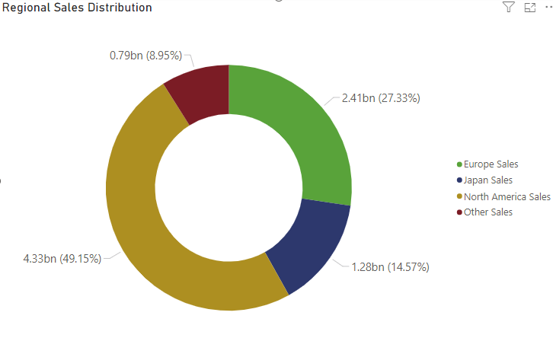

Donut Chart showing Regional Sales

For sales distribution, the analysis revealed that the majority of video game sales came from specific platforms, with consoles such as PlayStation and Wii showing higher global sales compared to PC games and others.

A significant upward trend was observed in video game sales starting from the 1960s, peaking around 2007-2010, with a notable reduction in sales in the last few years.

In regional performance, North America emerged as the largest market, accounting for a significant portion of global sales (49.15%), followed by Europe (27.33%) and Japan (14.57%). The "Other" category showed potential growth in emerging markets, suggesting a shift in consumer behavior.

Genres such as Action, Sports and Shooter, demonstrated the highest sales volumes, $1.72bn, $1.31bn and $1.03bn respectively, indicating strong consumer demand for these types of games.

**DISCUSSION OF INSIGHTS**

The findings underscore the dynamic nature of the video game industry, where consumer preferences can shift rapidly. The dominance of certain platforms and genres suggests opportunities for developers and publishers to focus on popular titles and explore emerging markets. The upward sales trend indicates a healthy market environment, likely supported by technological advancements and increased accessibility.

Furthermore, the regional analysis provides insight into localization strategies for publishers aiming to penetrate specific markets. The success of franchises in popular genres could guide future game development and marketing strategies.

**CONCLUSION**

This analysis of over 16,500 video games highlights critical trends and patterns in sales performance across various dimensions. By leveraging Power BI's analytical capabilities, key insights have been drawn that can inform stakeholders in the video game industry. As the market continues to evolve, ongoing analysis of sales data will be essential for understanding consumer behavior and optimizing product offerings. Future research could further explore the impact of digital distribution and emerging technologies on game sales trends.